Installation Steps for Humble Version

cd asha_ws/src

sudo apt install ros-humble-moveit

sudo apt install ros-humble-ros2-control

sudo apt install ros-humble-rqt-service-caller

git clone -b humble https://github.com/UniversalRobots/Universal_Robots_ROS2_Driver.git

vcs import src --skip-existing --input src/Universal_Robots_ROS2_Driver/Universal_Robots_ROS2_Driver.humble.repos

cd ..

colcon build --packages-select ur_robot_driver --cmake-args -DUR_ROBOT_DRIVER_BUILD_INTEGRATION_TESTS=On

rosdep install --ignore-src --from-paths src -y -r

colcon build --cmake-args -DCMAKE_BUILD_TYPE=Release

source install/setup.bash

vcs import src –skip-existing --input src/Universal_Robots_ROS2_Driver/MoveIt_Support.repos

vcs import src --skip-existing --input src/moveit2/moveit2.repos

rosdep install --ignore-src --from-paths src -y -r

colcon build --cmake-args -DCMAKE_BUILD_TYPE=Release

source install/setup.bash

colcon build --packages-select ur_robot_driver --cmake-args -DUR_ROBOT_DRIVER_BUILD_INTEGRATION_TESTS=On

sudo apt-get update && sudo apt-get upgrade -y && sudo apt-get dist-upgrade -y

sudo apt-get install python3-colcon-ros

sudo apt-get install python3-colcon-bash

sudo apt update && sudo apt install curl gnupg2 lsb-release

sudo curl -sSL https://raw.githubusercontent.com/ros/rosdistro/master/ros.key -o /usr/share/keyrings/ros-archive-keyring.gpg
echo "deb [arch=$(dpkg --print-architecture) signed-by=/usr/share/keyrings/ros-archive-keyring.gpg] http://packages.ros.org/ros2/ubuntu $(source /etc/os-release && echo $UBUNTU_CODENAME) main" | sudo tee /etc/apt/sources.list.d/ros2.list > /dev/null

ifconfig
ping 192.168.56.1
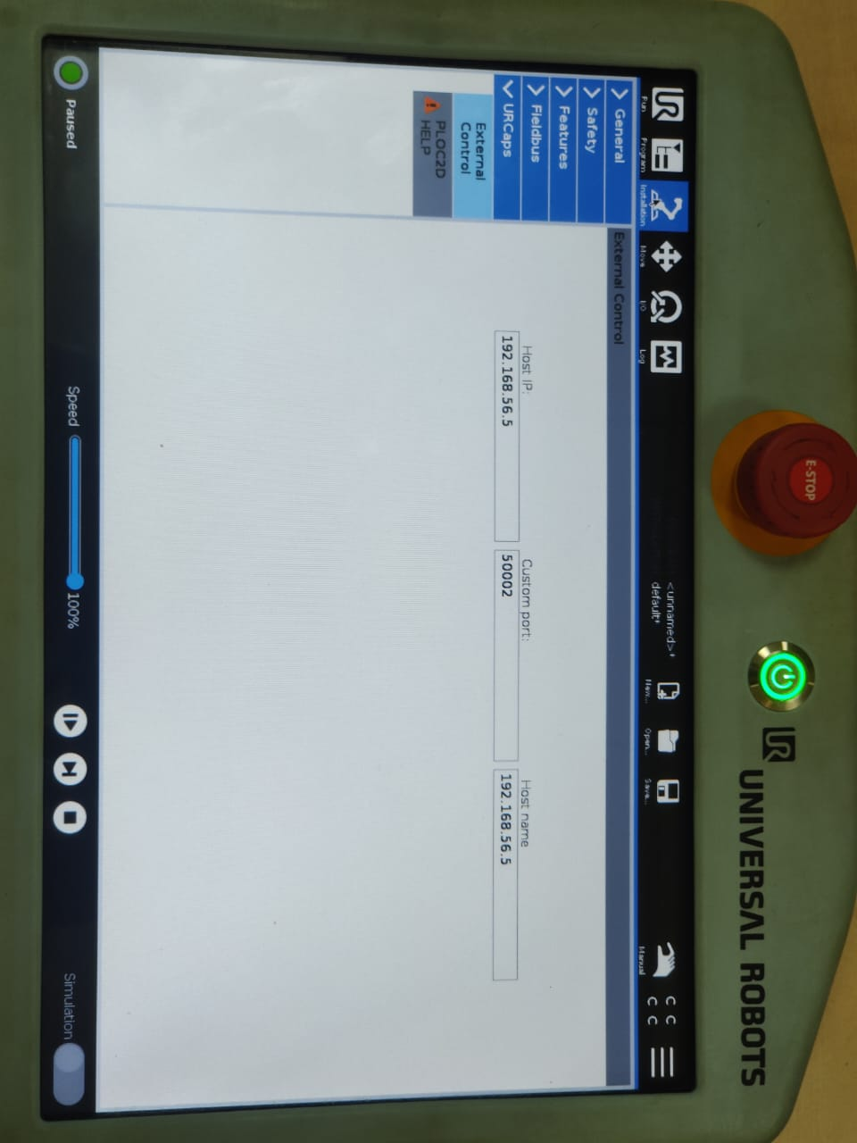
ros2 launch ur_bringup ur5e.launch.py robot_ip:=192.168.56.1
ros2 launch ur_moveit_config ur_moveit.launch.py ur_type:=ur5e robot_ip:=192.168.56.1
ros2 launch ur5_moveit spawn_ur5_launch_moveit.launch.py ur_type:=ur5e robot_ip:=192.168.56.1

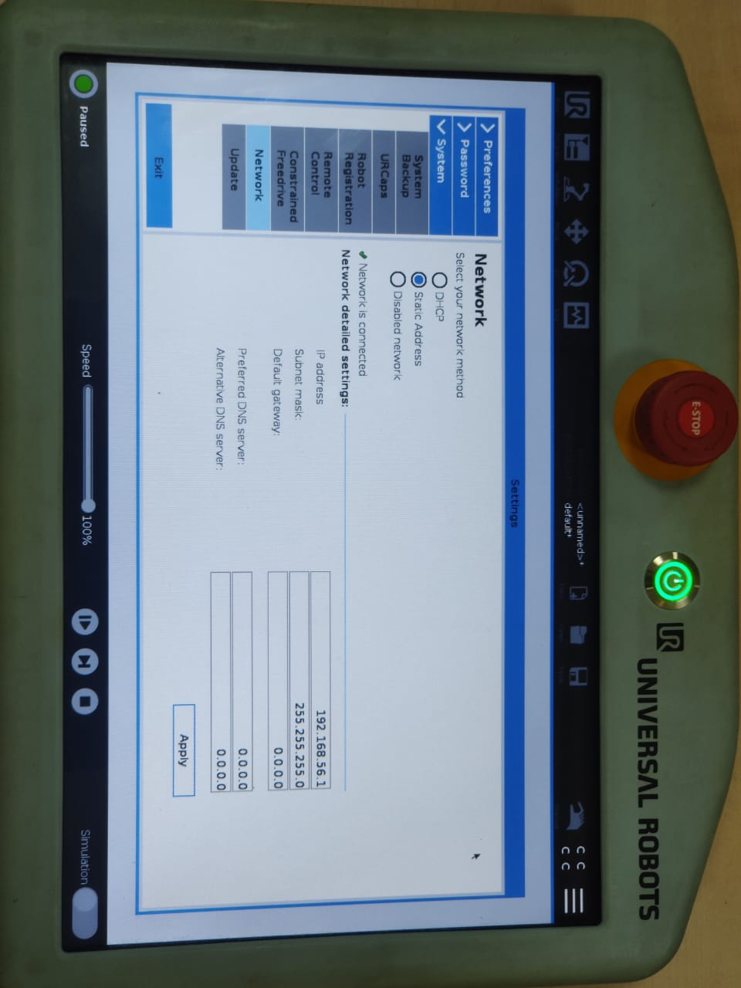

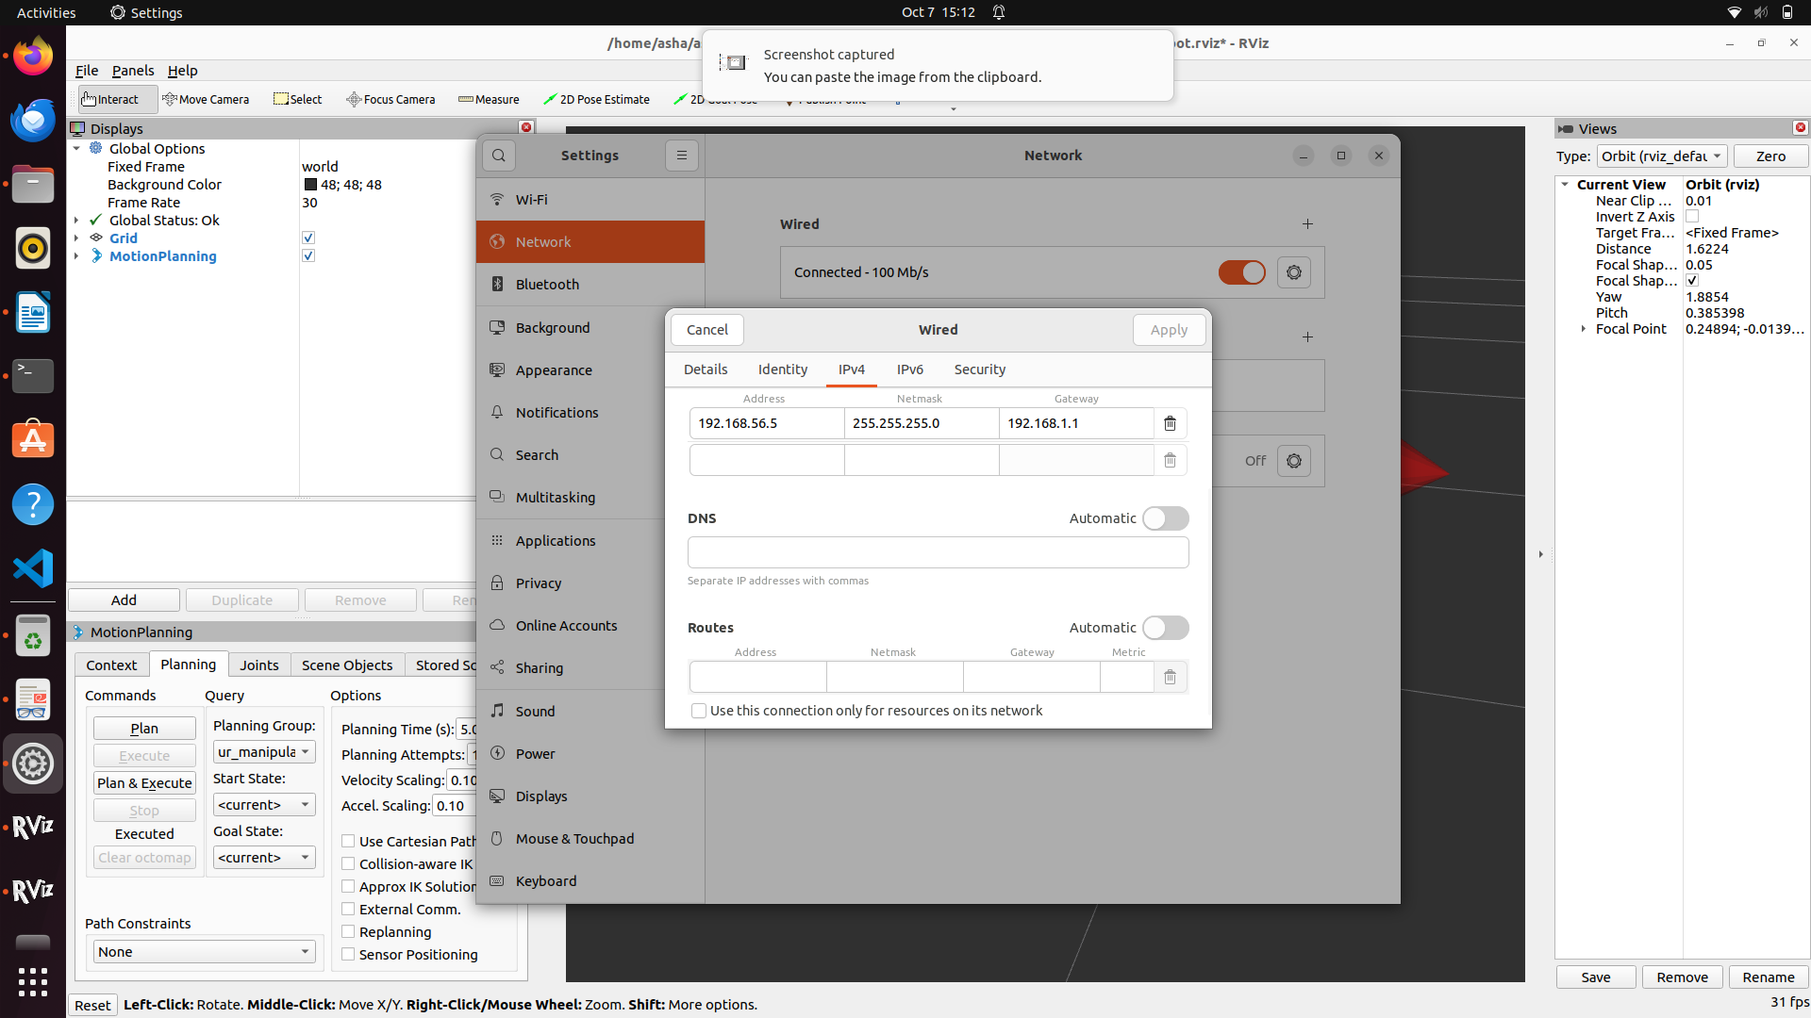

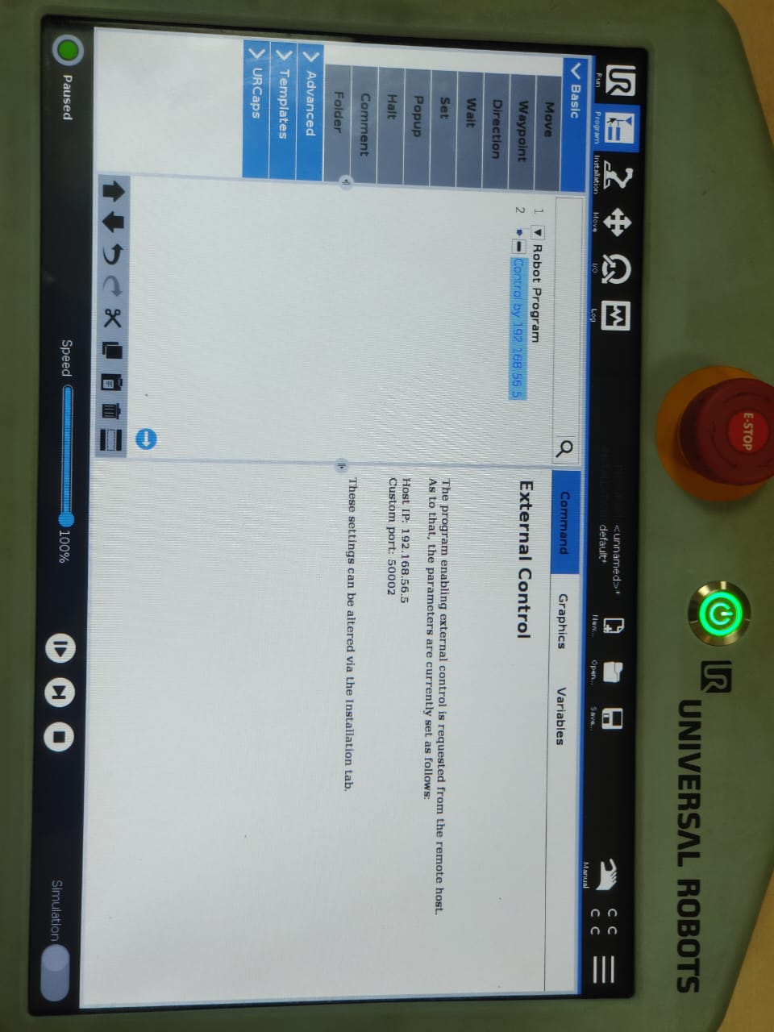

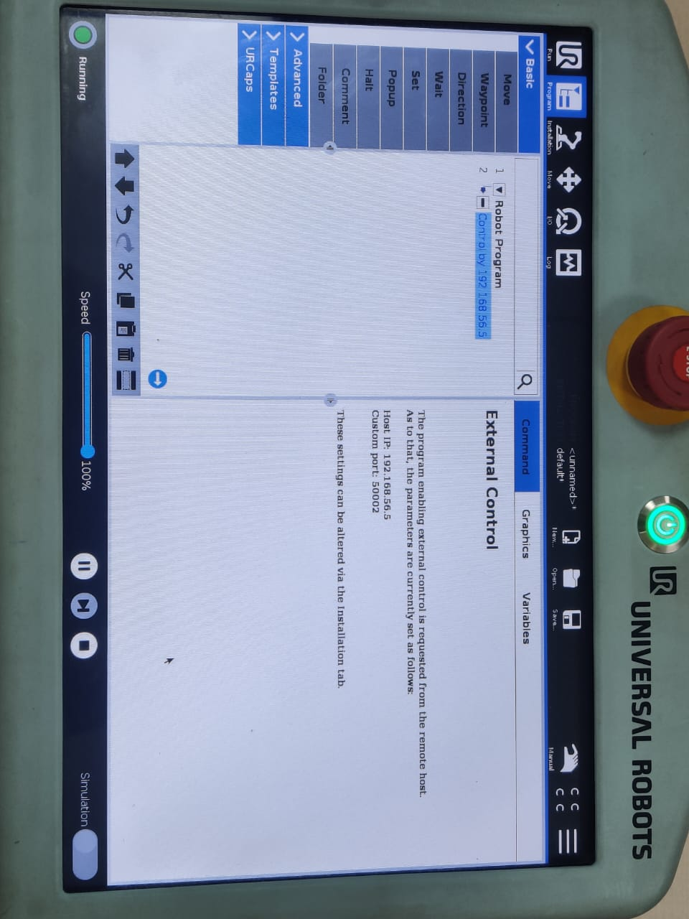
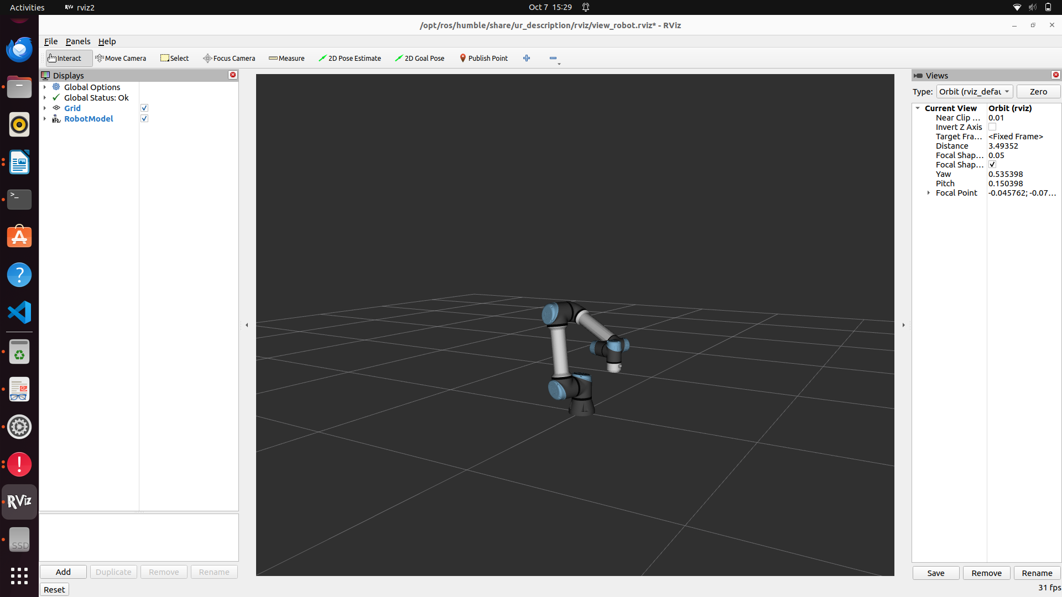

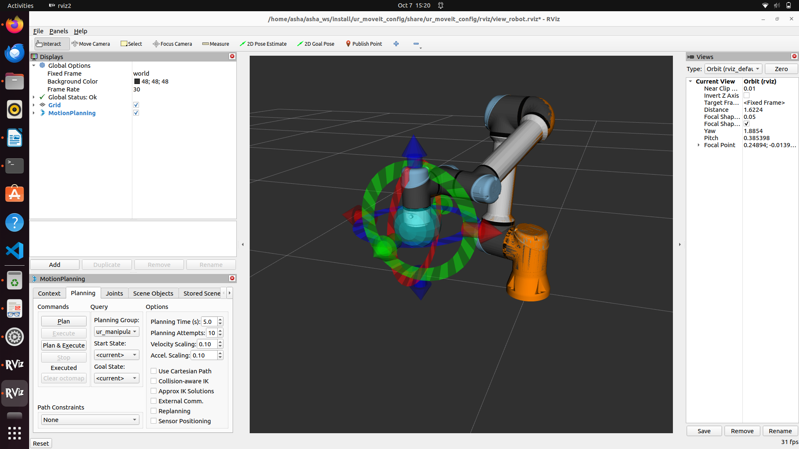

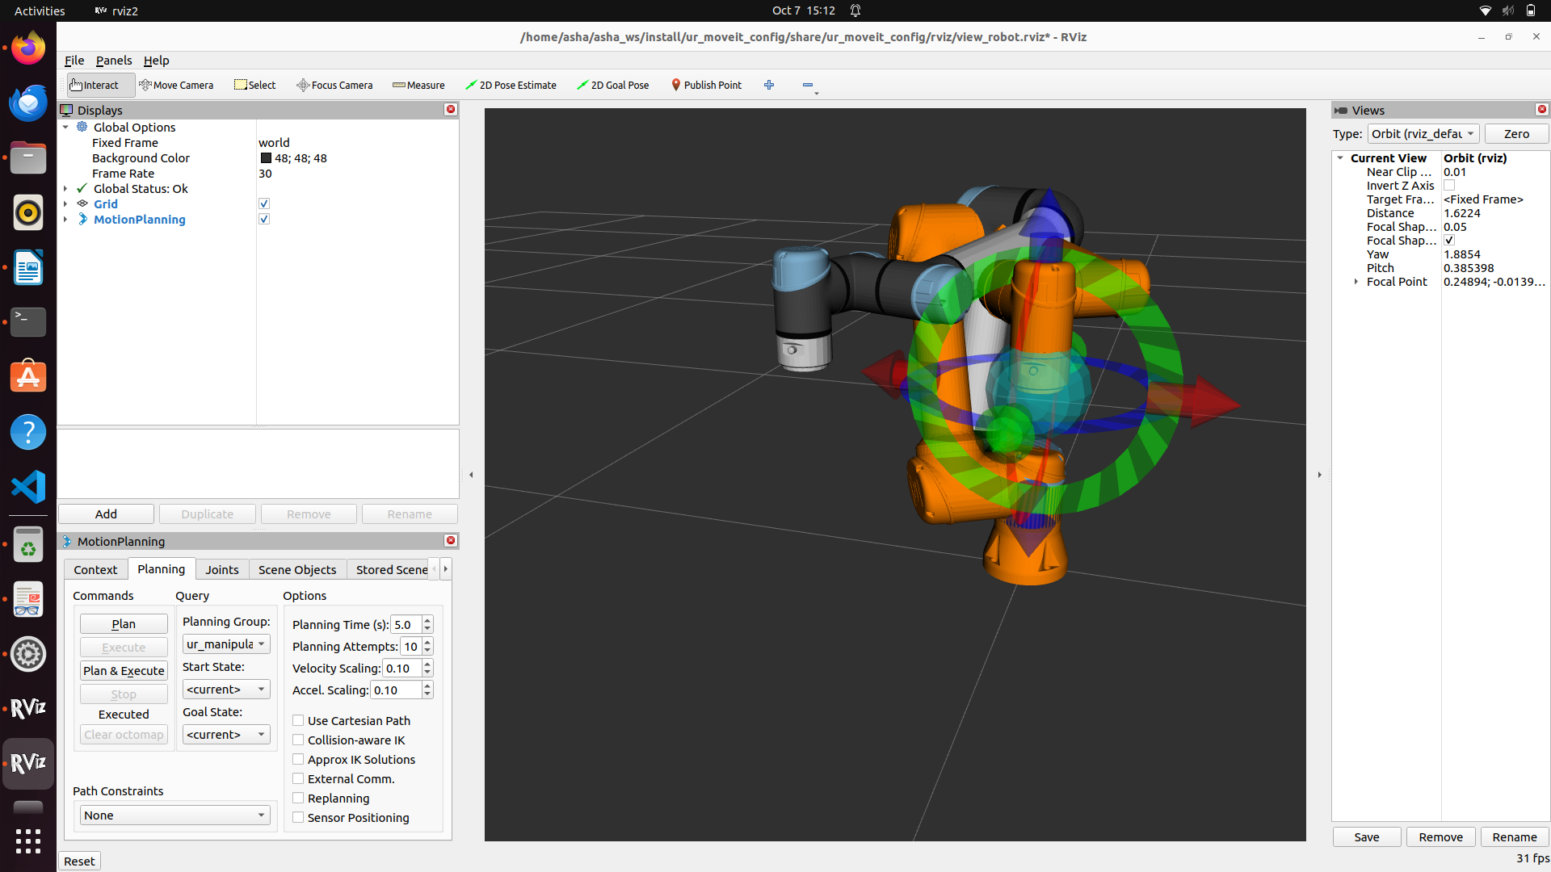

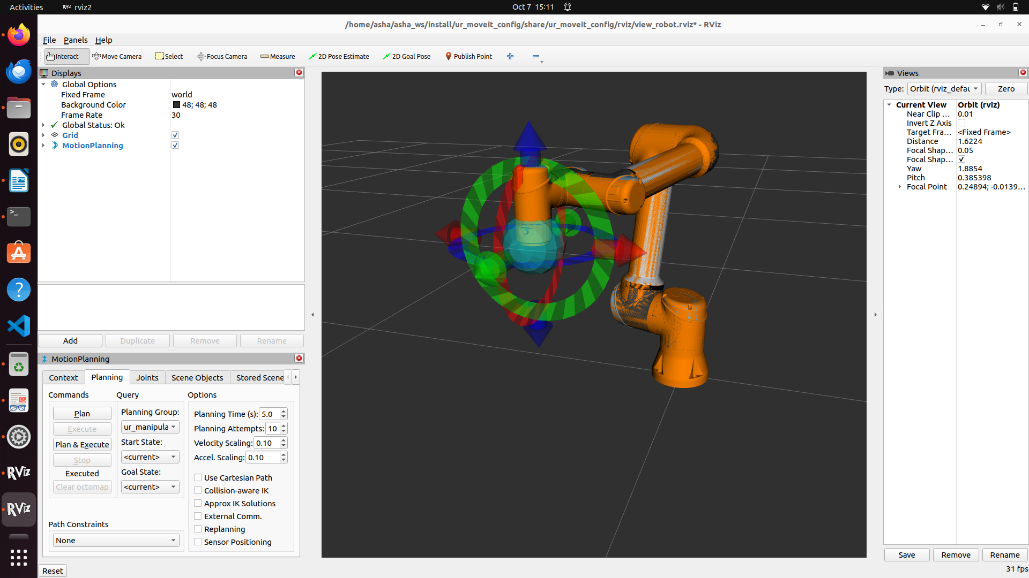

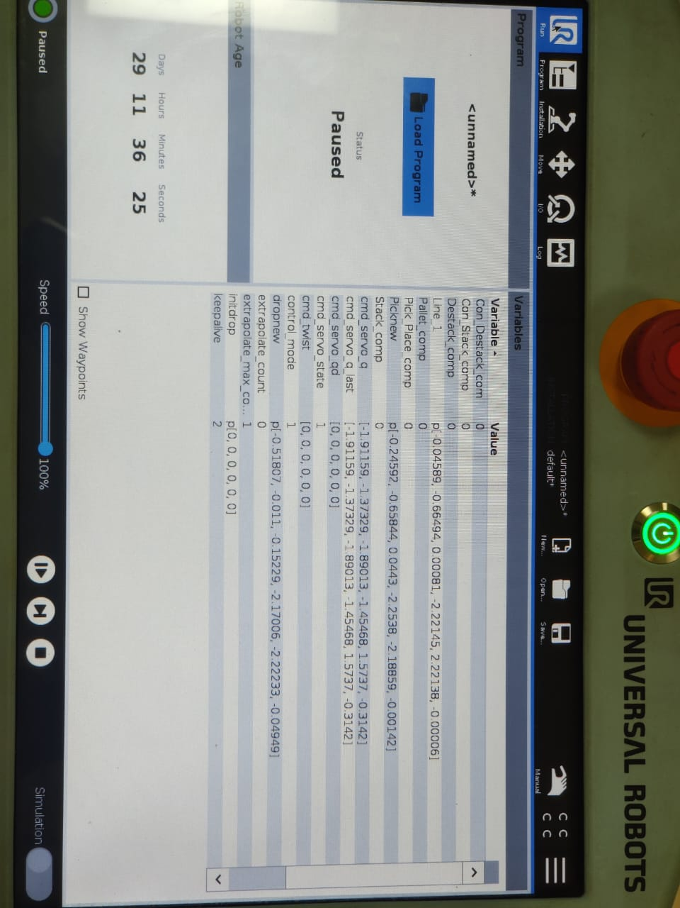

Moveit 2:
cd asha_ws/src

ros2 pkg create –build-type ament_cmake ur5e_moveit
cd ..
colcon build-type

add config

